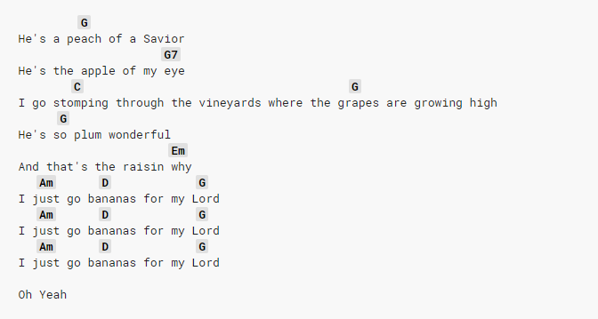

https://tabs.ultimate-guitar.com/tab/misc-praise-songs/peach-of-a-savior-chords-2280377

https://tabs.ultimate-guitar.com/tab/misc-praise-songs/peach-of-a-savior-chords-2280377

